Name: Madireddy Mahesh

Batch: March 1st 2022

Tutor: Raham Shaik

Project Name: Configuration Through Ansible

* Ansible Configuration on Amazon Linux:

1. Create 3 Ec2 instances with Amazon Linux Ami

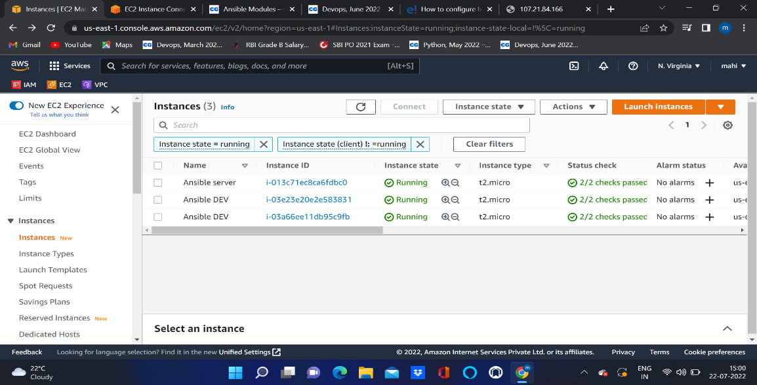

2. Configured ansible on the Master node.

3. Generate key pairs to establish the communication between master and worker nodes.

4. To checker weather the communication is properly established are not we use adhoc commands.

5. If it is successfully executed adhoc commands then we can understand that configuration established successfully.

6. Create one yml file (Task. Yml)

7.Here why we are using yml means ansible playbooks are written in yml language .

8. wrote playbook using yml script

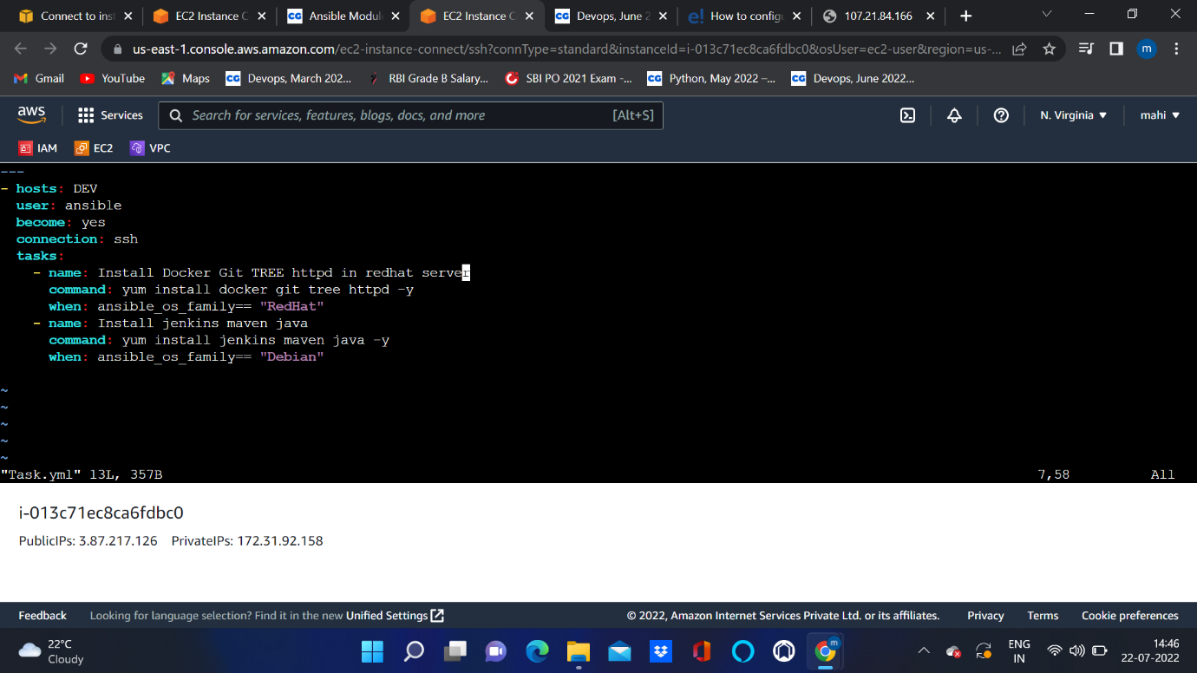

9. After writing playbook save that playbook by using(:wq)

10. To run the playbook we are using the command called (ansible—playbook playbookname.yml).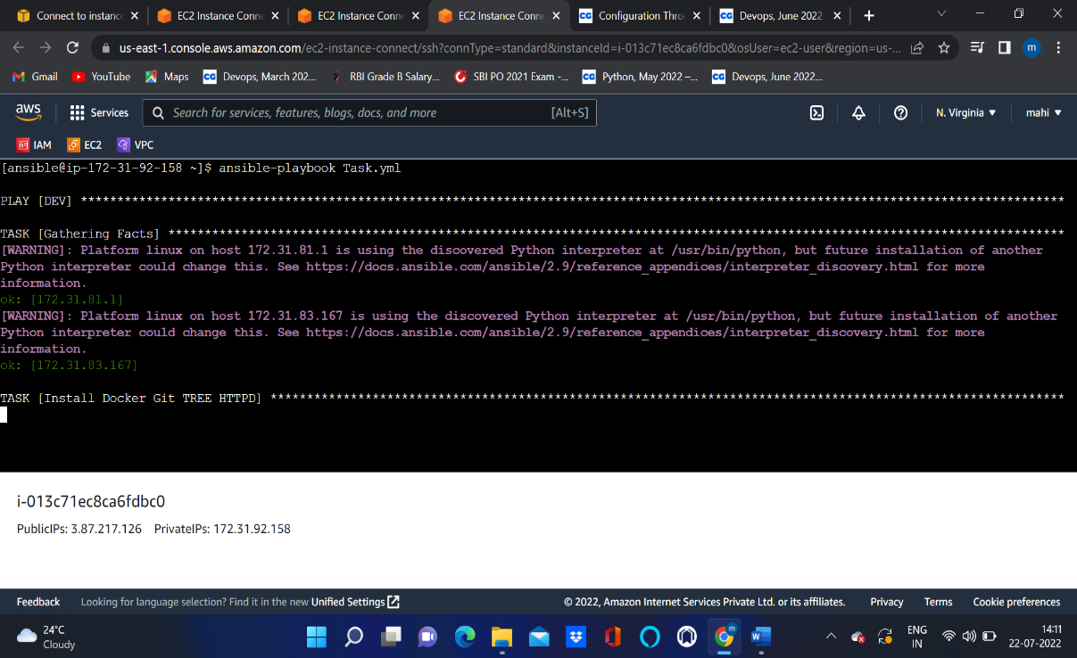

11. we can check log that packages installed properly are not.

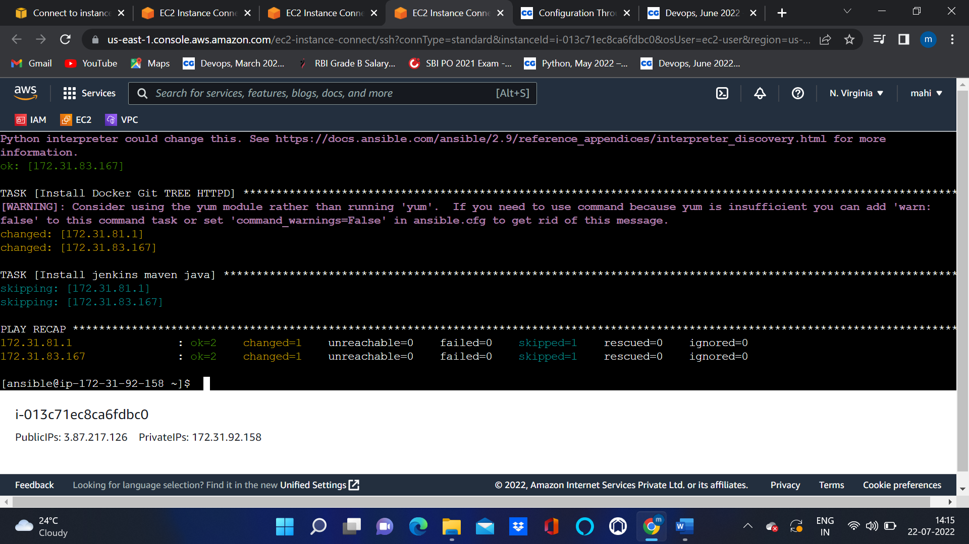

12. we can check configuration is done as per the playbook are not by opening node server and give command called ( --version).

